

### Semester Two Examination, 2019

### Question/Answer booklet

# MATHEMATICS

**METHODS**

**UNITS 1 AND 2**

## Section One:

## Calculator-free

Your name _________________________________________

## Time allowed for this section

Reading time before commencing work: five minutes

Working time: fifty minutes

## Materials required/recommended for this section

***To be provided by the supervisor***

This Question/Answer booklet

Formula sheet

***To be provided by the candidate***

Standard items: pens (blue/black preferred), pencils (including coloured), sharpener,  
correction fluid/tape, eraser, ruler, highlighters

Special items: nil

## Important note to candidates

No other items may be taken into the examination room. It is **your** responsibility to ensure that you do not have any unauthorised material. If you have any unauthorised material with you, hand it to the supervisor **before** reading any further.

## Structure of this paper

| Section | Number of questions available | Number of questions to be answered | Working  time (minutes) | Marks available | Percentage of examination |
| --- | --- | --- | --- | --- | --- |
| Section One:  Calculator-free | 8 | 8 | 50 | 52 | 35 |
| Section Two:  Calculator-assumed | 13 | 13 | 100 | 98 | 65 |
|  | | |  | **Total** | 100 |

| Markers use only | | |
| --- | --- | --- |
| Question | Maximum | Mark |
| 1 | 4 |  |
| 2 | 5 |  |
| 3 | 8 |  |
| 4 | 7 |  |
| 5 | 7 |  |
| 6 | 8 |  |
| 7 | 6 |  |
| 8 | 7 |  |
| S1 Total | 52 |  |
| S1 Wt (×0.6731) | 35% |  |
| S2 Wt | 65% |  |
| Total | 100% |  |

## Instructions to candidates

1. The rules for the conduct of examinations are detailed in the school handbook. Sitting this examination implies that you agree to abide by these rules.

2. Write your answers in this Question/Answer booklet preferably using a blue/black pen.  
Do not use erasable or gel pens.

3. You must be careful to confine your answer to the specific question asked and to follow any instructions that are specified to a particular question.

4. Show all your working clearly. Your working should be in sufficient detail to allow your answers to be checked readily and for marks to be awarded for reasoning. Incorrect answers given without supporting reasoning cannot be allocated any marks. For any question or part question worth more than two marks, valid working or justification is required to receive full marks. If you repeat any question, ensure that you cancel the answer you do not wish to have marked.

5. It is recommended that you do not use pencil, except in diagrams.

6. Supplementary pages for planning/continuing your answers to questions are provided at the end of this Question/Answer booklet. If you use these pages to continue an answer, indicate at the original answer where the answer is continued, i.e. give the page number.

7. The Formula sheet is not to be handed in with your Question/Answer booklet.

**Section** **One: Calculator-****free** **35% (****52 Marks)**

This section has**eight (****8)** questions. Answer **all** questions. Write your answers in the spaces provided.

Working time: 50 minutes.

**Question 1 (4 marks)**

The line segment between the points $A(-2, -3)$ and $B(-2, 5)$ is the diameter of a circle.

Determine the equation of circle in the form $x^{2}+ax+y^{2}+by=c$, where $a, b$ and $c$ are constants.

**Question 2 (5 marks)**

Determine the gradient of the curve $y=x^{2}-3x-40$ at the point(s) where it crosses the $x$-axis.

**Question 3 (8 marks)**

(a) Simplify $(3a+2\sqrt{a})(3a-2\sqrt{a})$. (2 marks)

(b) Solve the equation $8^{x}=\sqrt{2} \underline{32}$ for $x$. (3 marks)

(c) Sketch the graph of $y=2^{(1-x)}$ on the axes below. (3 marks)

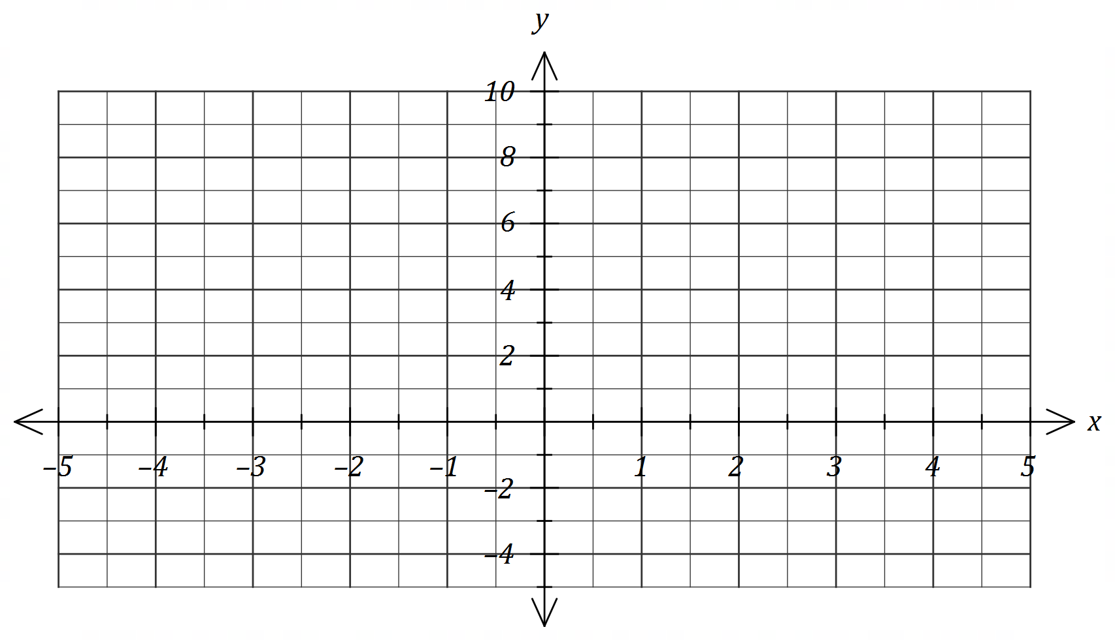

**Question 4 (7 marks)**

Small body $A$ is moving along a straight line so that at any time $t$ seconds, its displacement relative to a fixed point $O$ on the line is given by $x=t^{3}-3t^{2}+5$ cm.

(a) Determine the velocity of $A$ when $t=3$. (2 marks)

(b) Determine the displacement of $A$ relative to $O$ at the instant(s) that it is stationary.

(3 marks)

Small body $B$ has velocity given by $v=6t^{2}+2t-3$ cm/s and when $t=2$ it has a displacement of $3$ cm relative to $O$.

(c) Determine an expression for the displacement of $B$ relative to $O$ at any time $t$. (2 marks)

**Question 5 (7 marks)**

(a) Using Pascal's triangle, or otherwise, determine $\left(4 2 \right)$. (1 mark)

(b) Expand ${\left(x+1\right)}^{4}$. (2 marks)

(c) Hence, or otherwise, determine the equation of the tangent to the curve $y={\left(x+1\right)}^{4}$ at the point where $x=-2$. (4 marks)

**Question 6 (8 marks)**

(a) Solve the following equations.

(i) $tantan (2x) =\sqrt{3}$, $0≤x≤π$. (2 marks)

(ii) $2coscos (x-60°) =\sqrt{3}+coscos x$, $0°≤x≤360°$. (4 marks)

(b) The graph of $y=sinsin (ax+b)$ is shown below, where $a$ and $b$ are positive constants.

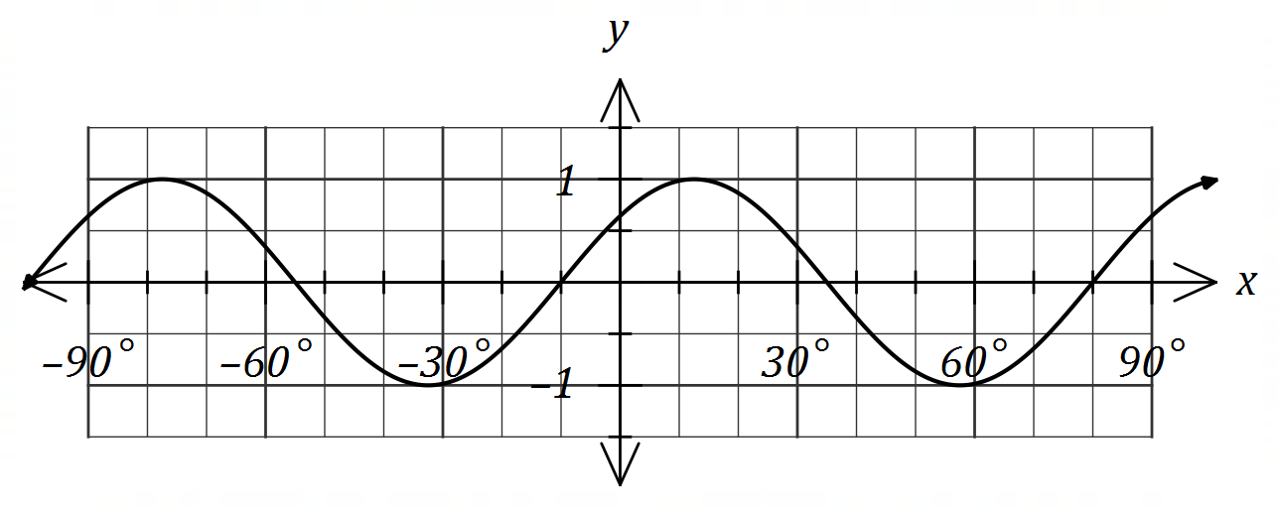

Determine the minimum possible value of each of the constants. (2 marks)

**Question 7 (6 marks)**

Determine the coordinates of all stationary points of the curve $y=x^{4}+2x^{2}-8x+9$.

**Question 8 (7 marks)**

An arithmetic sequence has a recursive definition given by $T_{n+1}=T_{n}+d, T_{1}=a$. It has third term of $40$ and tenth term of $12$.

(a) Determine the value of the constant $a$ and the constant $d$. (2 marks)

(b) Determine $T_{2019}$. (2 marks)

(c) The sum of the first $m$ terms of the sequence is $200$. Determine the value(s) of the integer constant $m$. (3 marks)

Supplementary page

Question number: _________

© 2019 WA Exam Papers. Kennedy Baptist College has a non-exclusive licence to copy and communicate this document for non-commercial, educational use within the school. No other copying, communication or use is permitted without the express written permission of WA Exam Papers. SN245-142-1.